**Hive – Udemy**

**What is Hive: -**

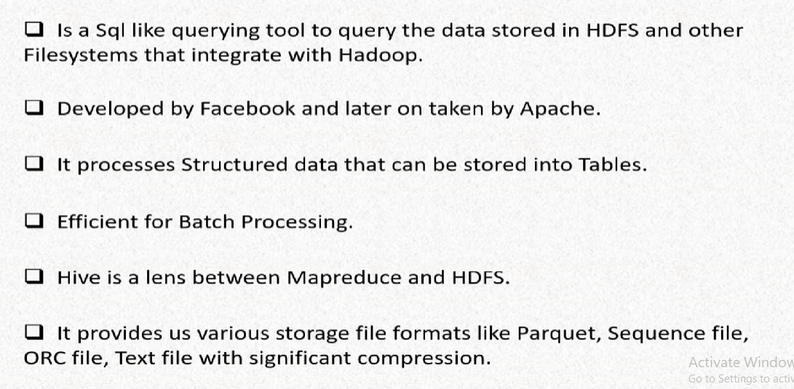

**What Hive is not: -**

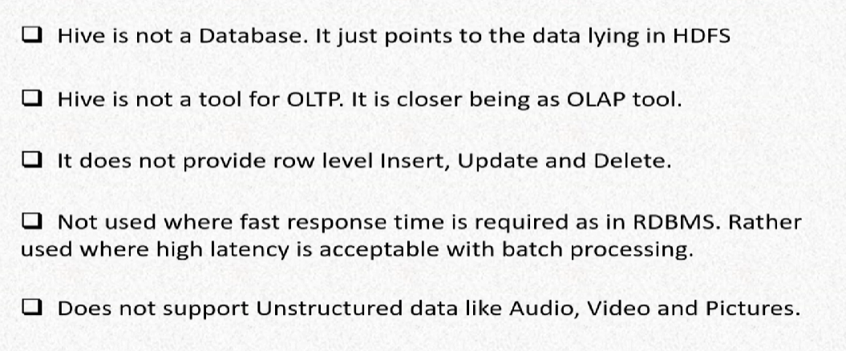

Motivation of Hive: -

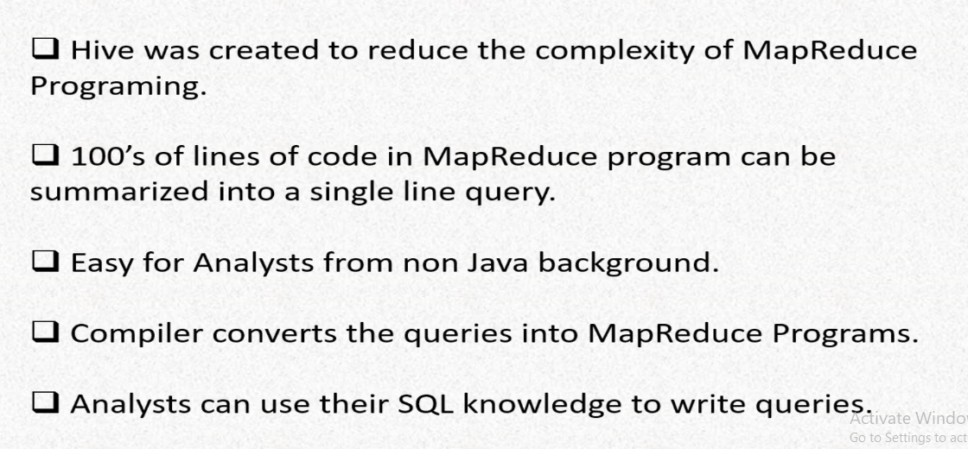

Hive vs SQL: -

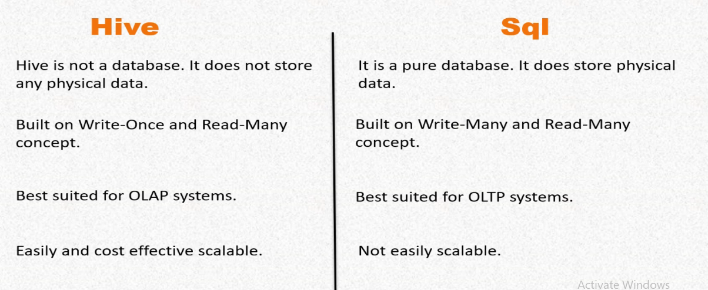

Practical starts from here-

Creating database: -

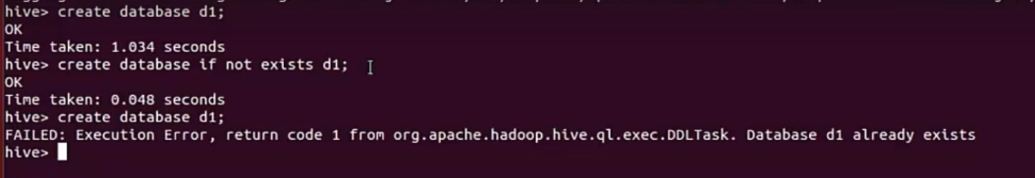

Creating database with comments: -

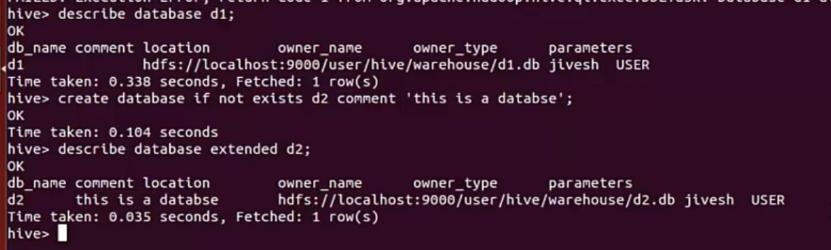

We can see the comment using ‘describe database db_name’ command as well.

Creating database with some parameters: -

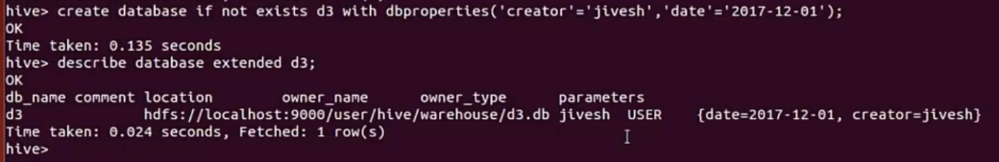

During Tables creating if we don’t select any Database in that case it will be created inside the Hive ‘default’ database.

Creating Internal table: -



* Row format delimited – Telling hive, each row of the data is delimited by some delimeters
* Stored as textfile – Store the file as text file

Default values are: -

* Row format delimitd
* Fields terminated by '\001'
* Lines terminated by '\n'
* Stored as textfile

Creating an internal table but in another location: -



* Meta data and the actual data is managed by hive

Loading the data: -

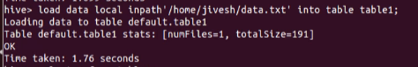

* Into will append the data with the present data
* Overwrite will clean the previous data and upload the new one

Internal vs External tables: -

* In case of **Internal tables**, the actual data and the meta data will be managed by hive no matter you store the data in the Hive warehouse or in HDFS
* We can’t access internal table data explicitly. We need to come thorough hive.
* If we drop the table metadata and the actual data will be deleted.
* In case of **External tables** only the meta data will be managed by hive and not the actual data
* If we drop the table in that case hive metadata will be deleted but actual data will be there
* If we don’t provide any location during table creation it will store the data in the warehouse but still Hive will not control this data.
* Other applications can access the data

Creating external tables: -

* Create external table if not exists table12(col1 string, col2 array<string>, col3 string, col4 int) row format delimited fields terminated by ‘,’ collection items terminated by ‘:’ lines terminated by ‘\n’ stored as textfile;

To show column names in hive: -

* Set hive.cli.print.header = true;

Inserting data to a table from another table: -

Our data set: -

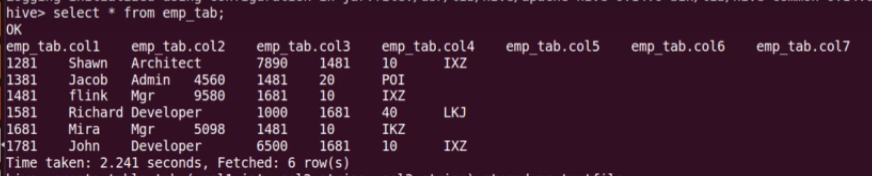

Creating table: -



* We can create as many columns as we want (of matching datatype)
* Here we have created 3 columns out of 7
* We don’t need to specify the delimiters, because we’ll be loading from a table and hive already has the metadata of it.

Inserting the data: -

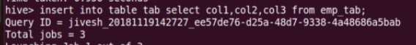

Our table: -

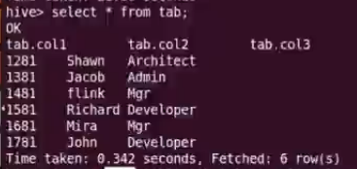

Overwrite clause: -



* It will delete all the data and then write the mentioned data

Our table: -

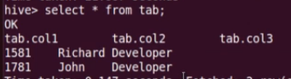

Inserting one table’s data into multiple tables: -

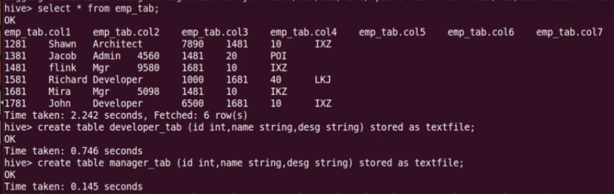



Show the data from developer table and manager table: -

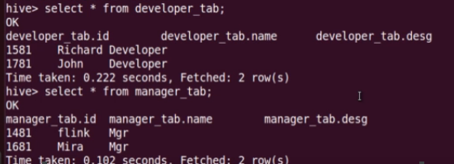

Altering tables: -

Adding new columns: -

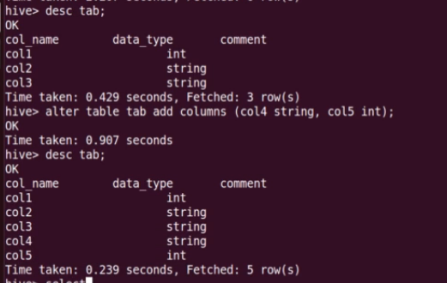

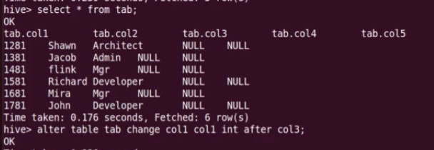

If you want to move a column after some another column: -

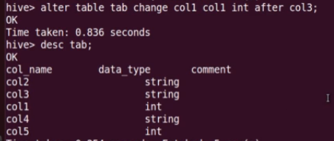

Col1 Col1 – old_col_name new_col_name

If you just want to change a column name: -

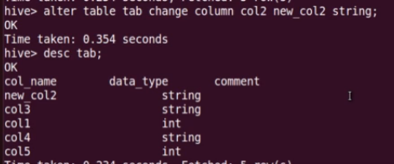

If you want to change a table name: -

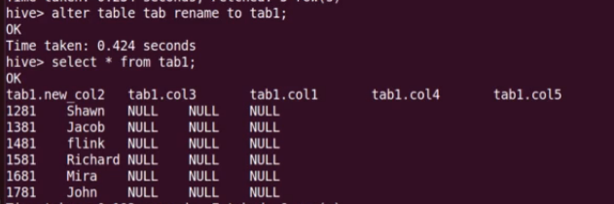

If you want to replace **all** the columns with some new columns: -

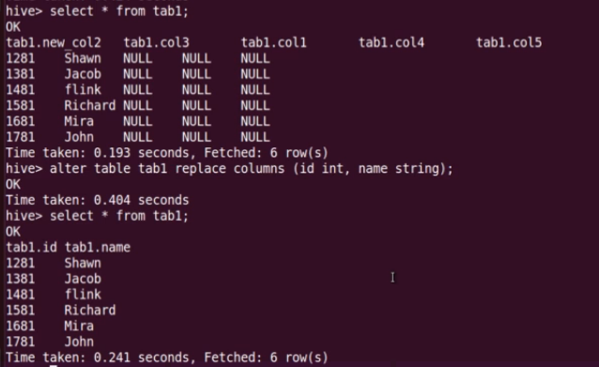

Alter table properties: -



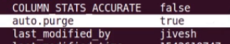

Changing the file format: -

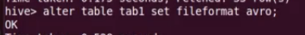

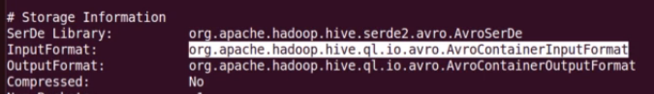

Sorting the data: -

* ORDER BY
* SORT BY
* DISTTIBUTED BY
* CLUSTERBY

ORDER BY: -

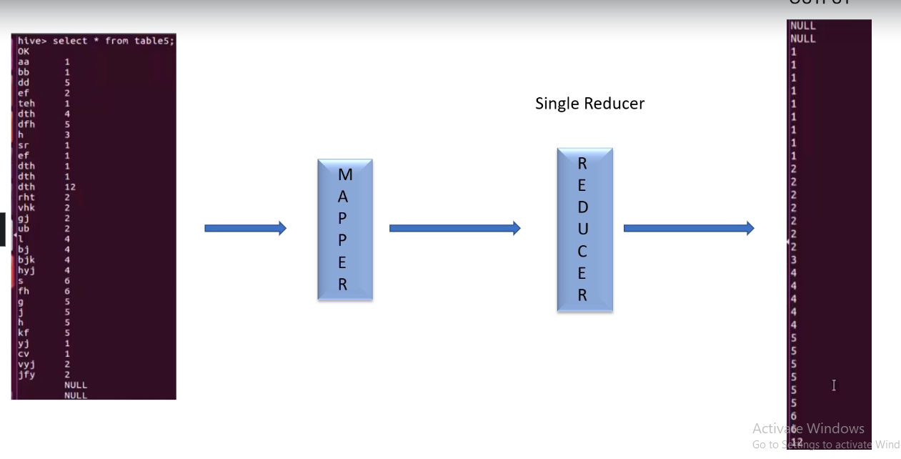



We must use a limit clause because it uses a single reducer for global sorting.

Sort by: -

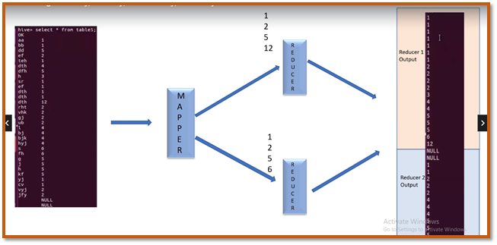



Distribute by: -

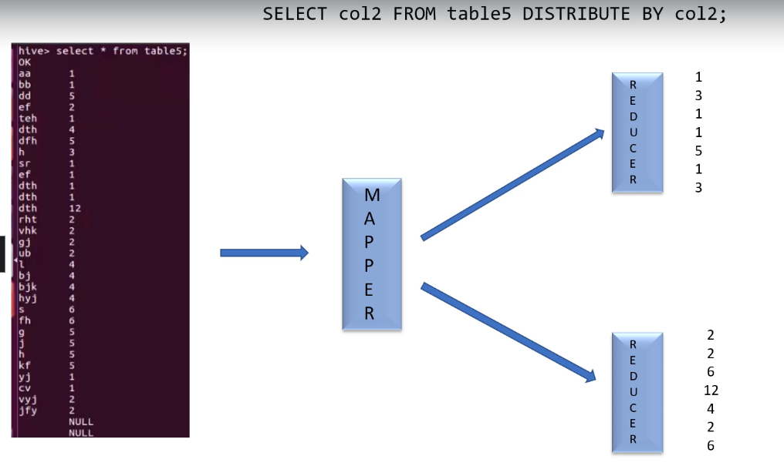

* Distribute by ensures that each of n reducers get non overlapping range of values
* Distribute by doesn’t do any kind of sorting

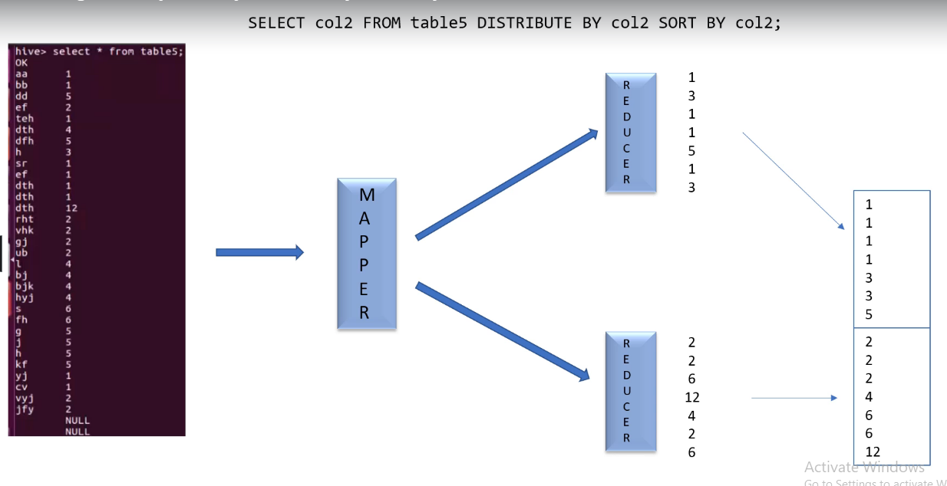

Cluster by: -

CLUSTER BY = DISTRIBUTE BY SORT BY



Some mathematical functions: -

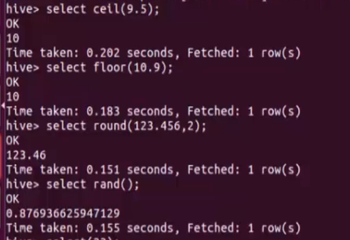

Some Date functions: -

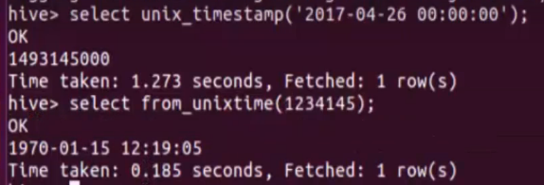

* Date to timestamp
* Timestamp to date

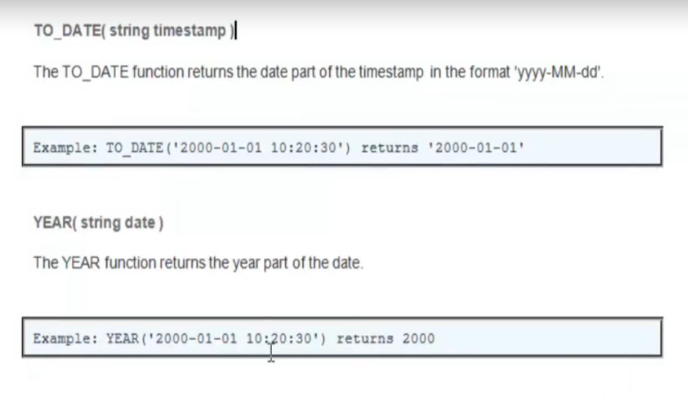

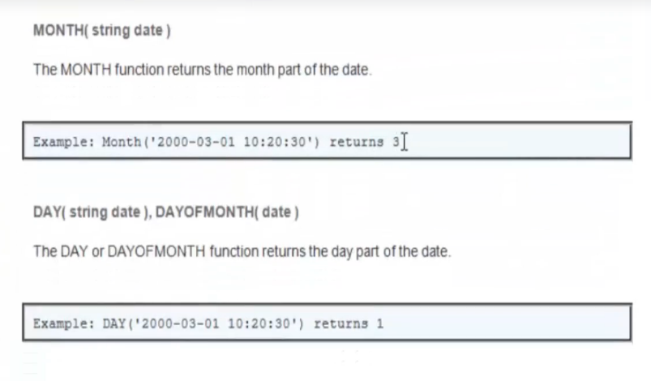

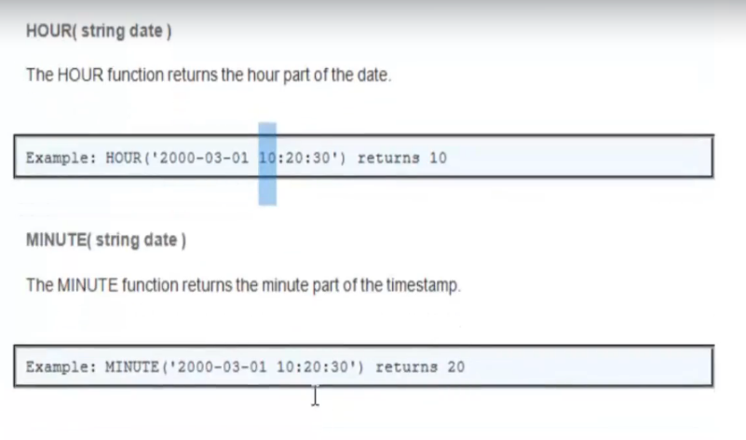

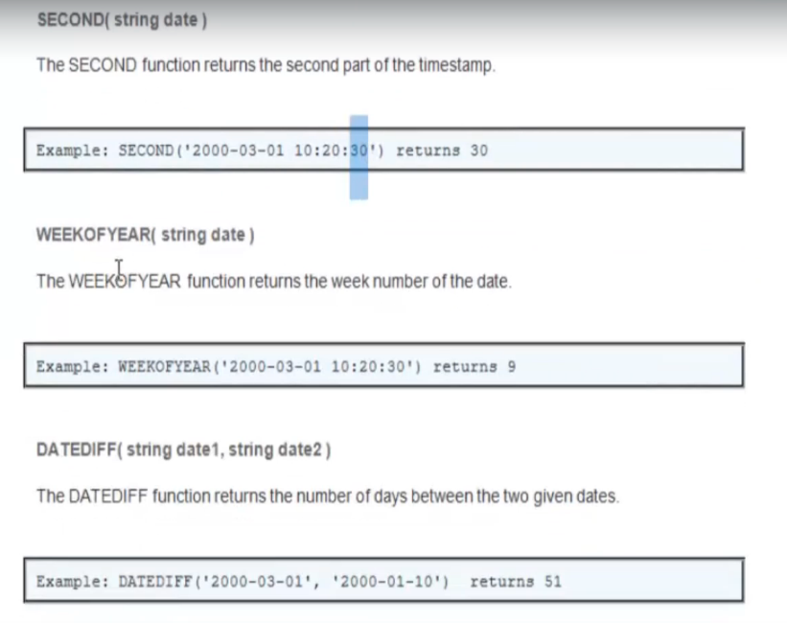

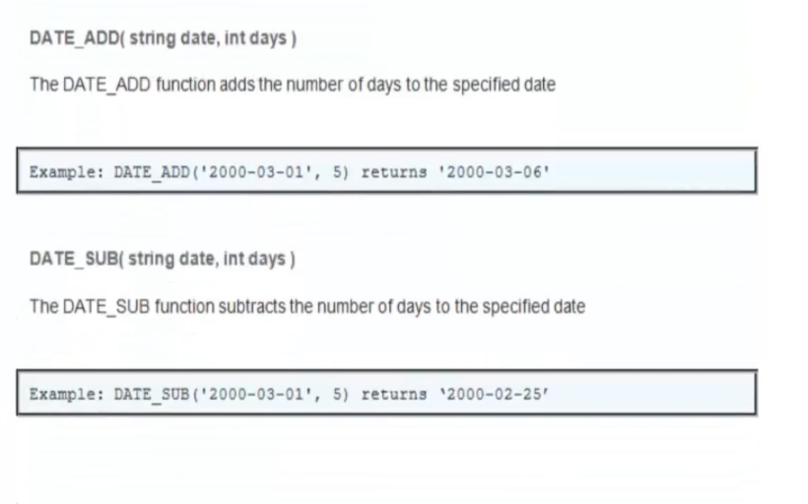

String functions: -

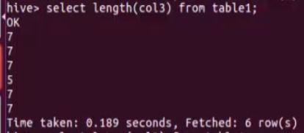

Other fuctions: -

* Concat()
* Upper()
* Lower()

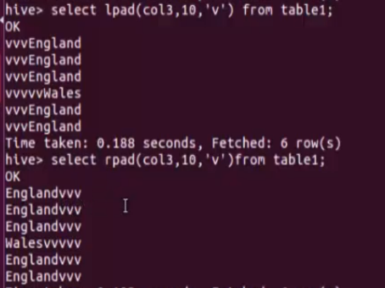

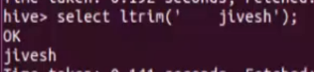

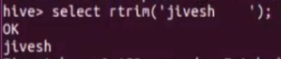

`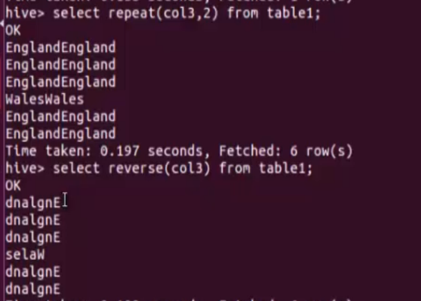

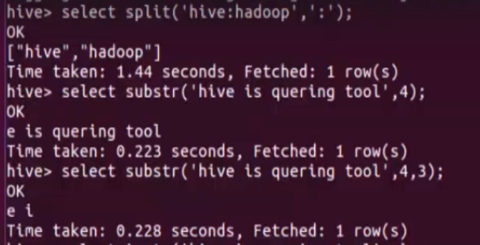

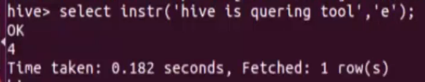

Substr()

* index starting from 1
* 4,3 – Starting position and how many characters you want

Conditional Statements: -

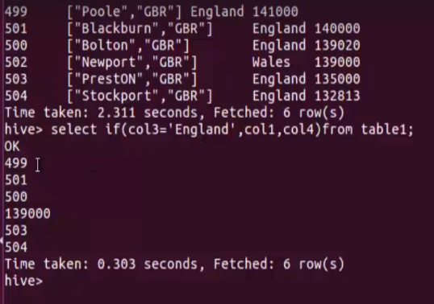

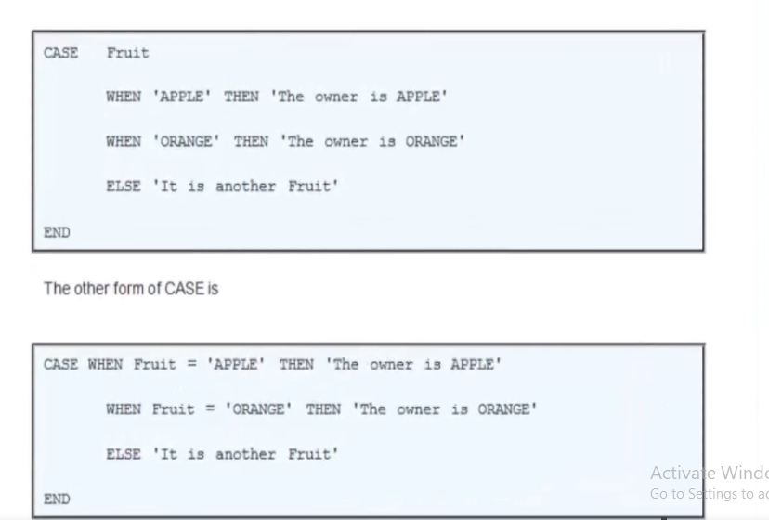

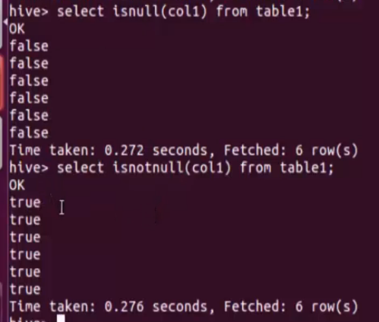

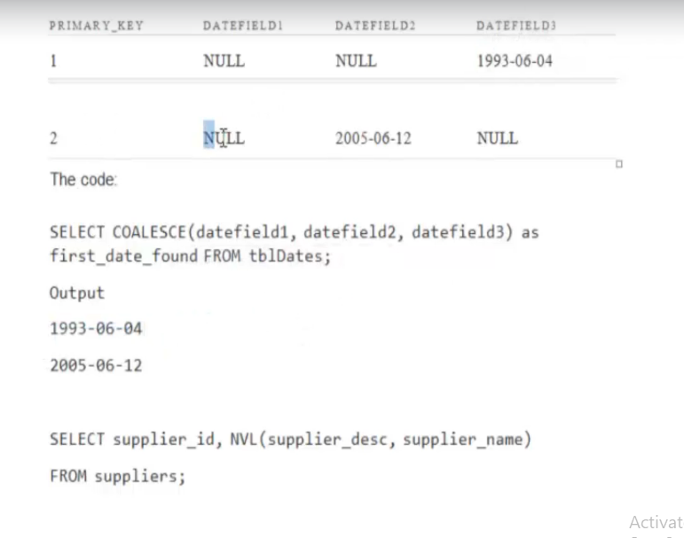

NVL: - if the first field is null it will select the second one and if the first is not null then it will choose the first one

Explode(): - Takes in an array as input and outputs the elements of array as separate rows

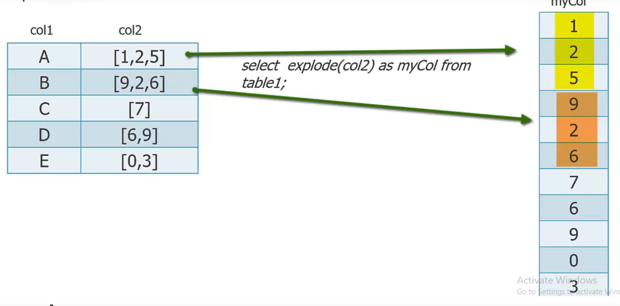

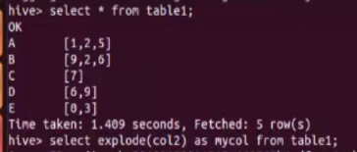

* The problem with the Explode function is, we can’t select any other column other than the Exploded one

Lateral view: -

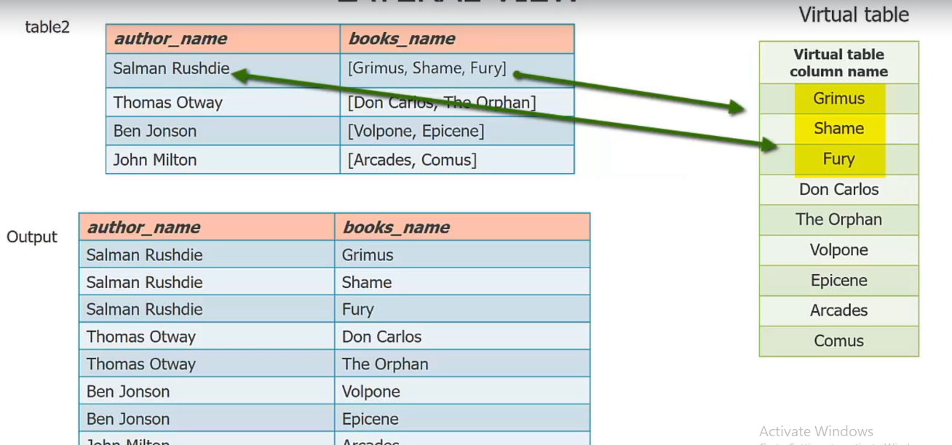

* It is the solution of the explode problem

Lateral view: -



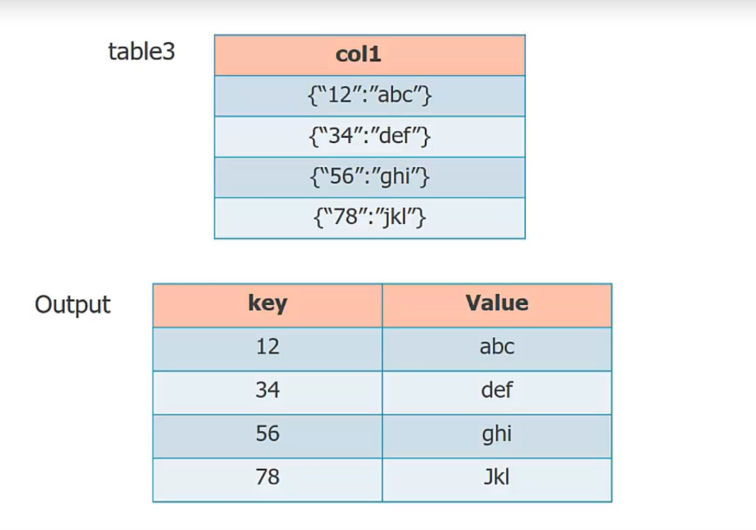



Rlike: -

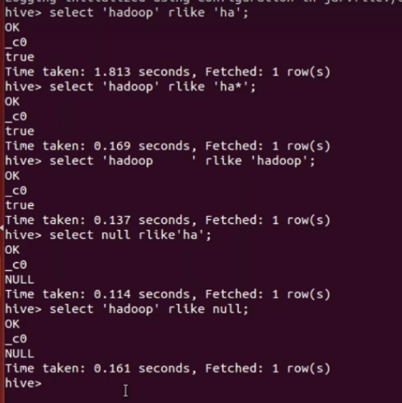

Rank function: -

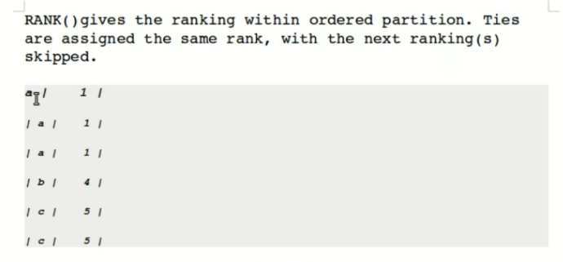

Dense_rank: -

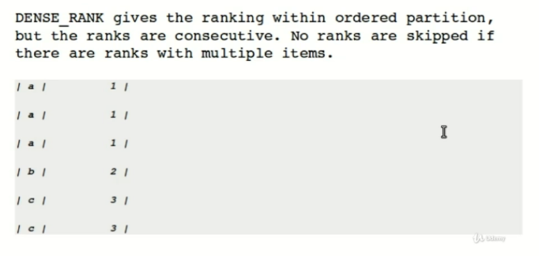

Row_number : -

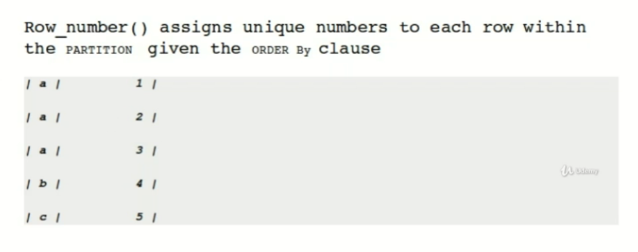

Data: -

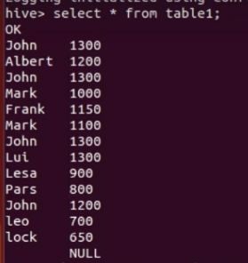







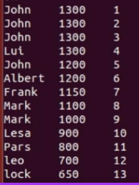





We can use this partition thing with dense_rank() as well

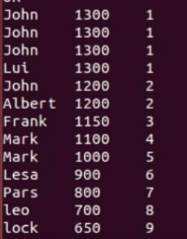

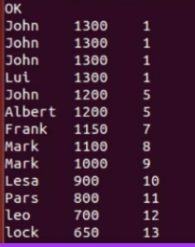

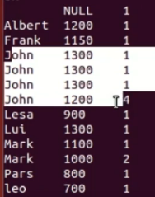

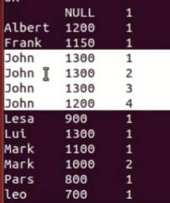

Partition: -

* Static
* Dynamic

Static partition: -



* In case of static partitioning, we do not include the partitioned column name in the partition table

Inserting the data: -



* If you have the data in separate files, you can directly load them as well



Dynamic partitioning: -

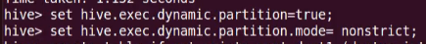

Table creation: -



Loading the data: -



* We don’t need to hard code the partition name
* The partitioned column in the select statement should be present at the last (col2)

Static partitioning is faster than dynamic one

Showing the available partitions, dropping a partition, and adding a partition: -

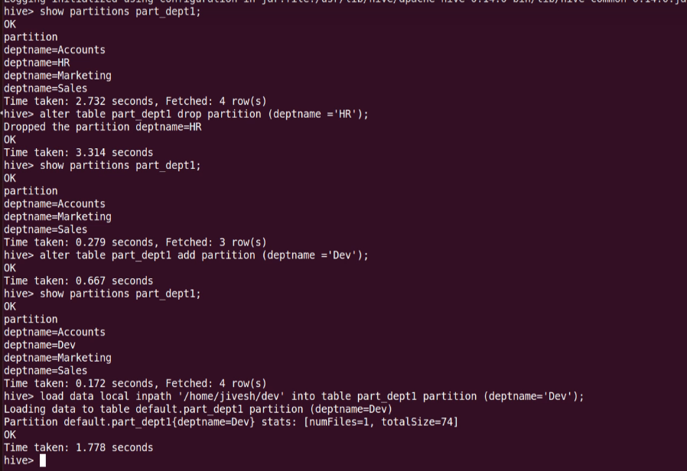

* If you put a directory in the partition table directory manually hive will not recognize it as a partion beacause hive don’t have the meta data

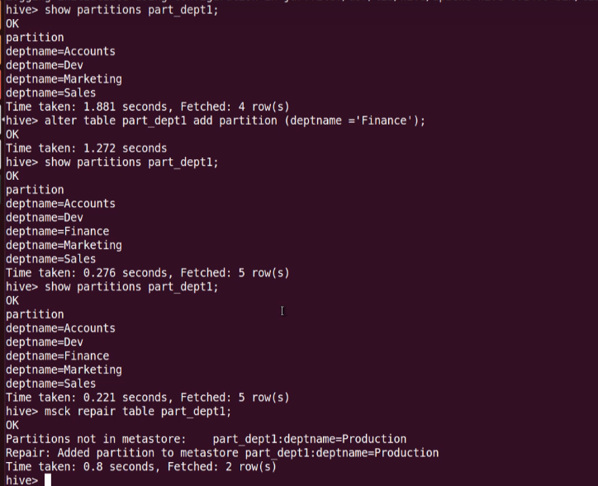

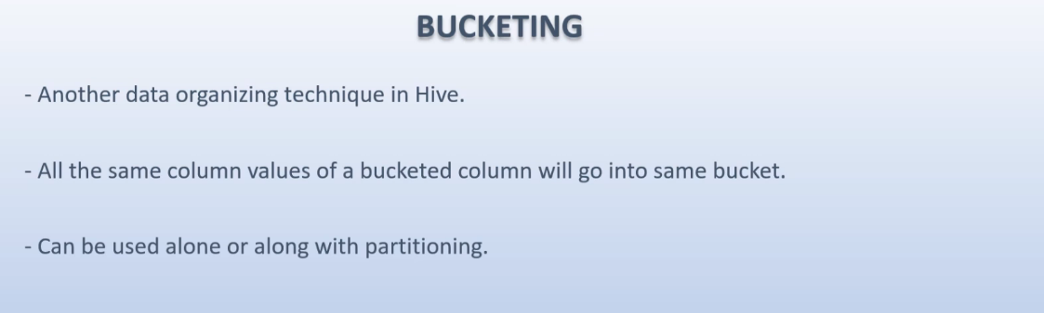

* It is best to use Bucketing along with the partitioning

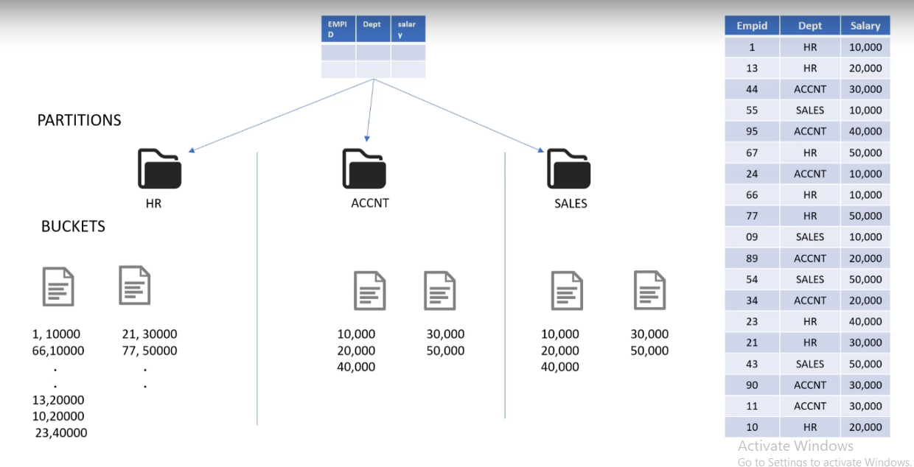

Creating a table with bucketing: -





* Number of buckets = number of reducers
* Each bucket contains non overlaping values

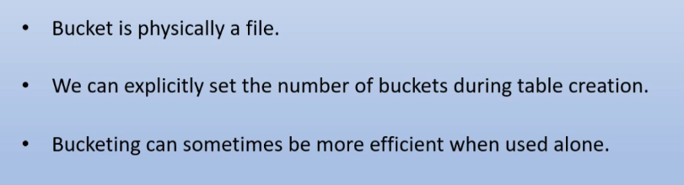

* If you have too diverse dataset in that case only bucketing will be more efficient than partitioning and bucketing together
* Bucketed Map joins are the fastest joins



Table Sampling: -



* It is deviding total number of bunckets into groups of 2 buckets each and then selecting the 1st buckets of each group



* It will get **at least** 2% of data

Select deptno, empname, sal, location from dept_buck tablesample (1M)

* Sample size must be 1MB

Select deptno, empname, sal, location from dept_buck tablesample (20 rows)

No_drop and offline: -







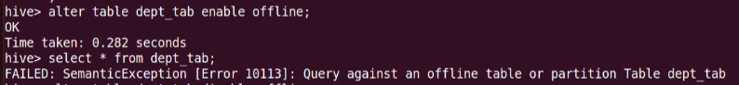

* It prevents the table to being quire



Data for joins: -

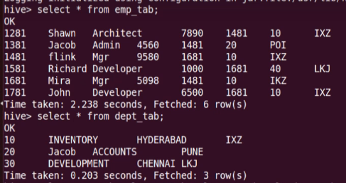

Inner join: -



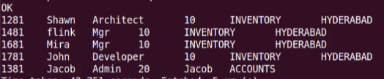

Left outer join: -



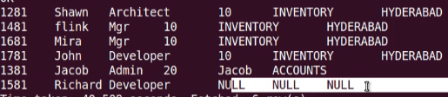

Right outer join: -



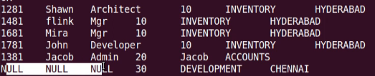

Right outer join: -



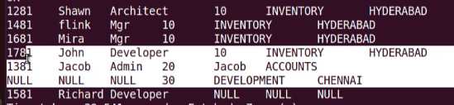

Join 3 tables in hive: -

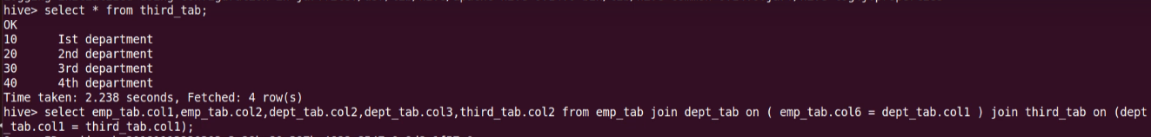



Memory management and optimization of joins: -

* Last table in query is streamed and rest are buffered in memory
* It is recommended that to put the larger dataset (Larger than our buffer memory) at last because it will be streamed by default
* Otherwise, we need to explicitly mention which table to stream



Map joins: -

In any map reduce joins the reducer step is slowest because it involves shaffling of data from various sources over the network



If we want to let hive to decide where to perform map joins: -

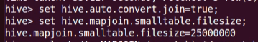

* You can’t perform full outer join using map joins. It will automatically involve reducers

Bucketed map joins: -

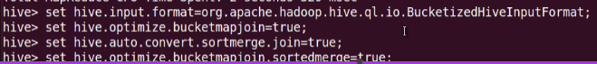

Views in Hive: -

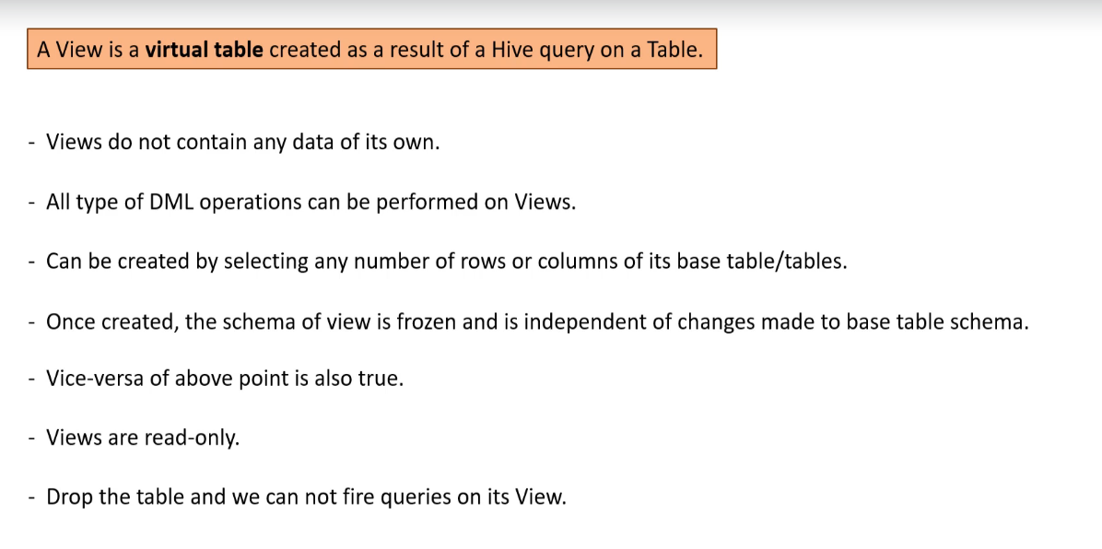

Creating a view: -



Creating views with different column names: -



Creating views along with join: -



Altering view data: -

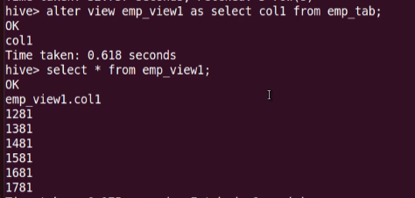

Renaming a view: -



Droping a view: -



Advantages of views: -

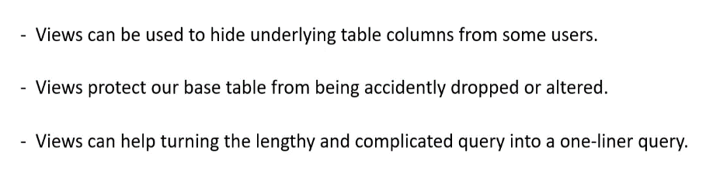

Indexes in hive: -

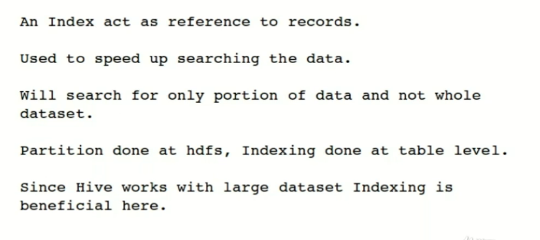

Our data: -

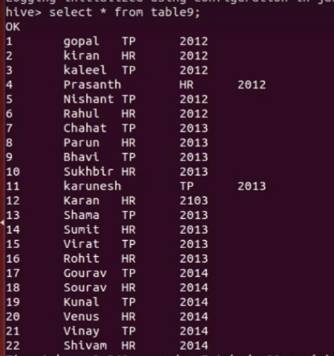

Creating an index: -



Updating our index: -



* When we first create an index table it will be empty
* After rebuild command the data will be populated in the index table

Types of indexes: -

* Compact
* Stores the pair of indexed column’s value and its block ID
* Bitmap
* Stores the combination of indexed column value and list of rows as a Bitmap

There are sometimes we see a difference between query fetching time in both.

Deferred rebuild: - We may need to alter the index table in future

Creating index table: -



Creating index on same table and on the same column: -

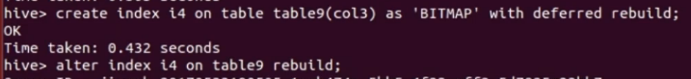

To show the indexs for a table: -



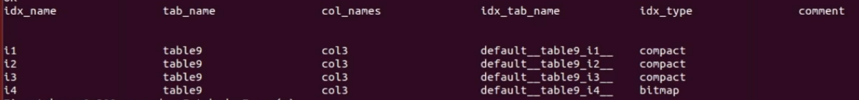

Droping an index: -



Using the index table: -



* It will use compact index because we have created it first
* To use other type of index we need to delete all the indexes created before it

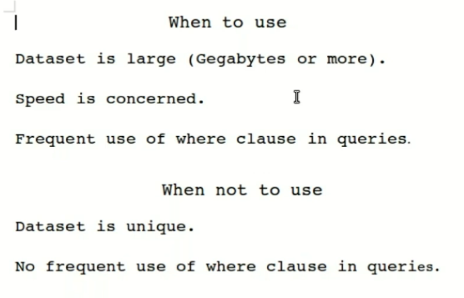

UDF’s: -

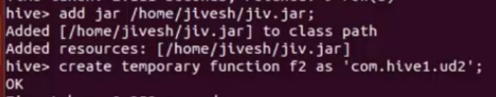

What is TEZ: -

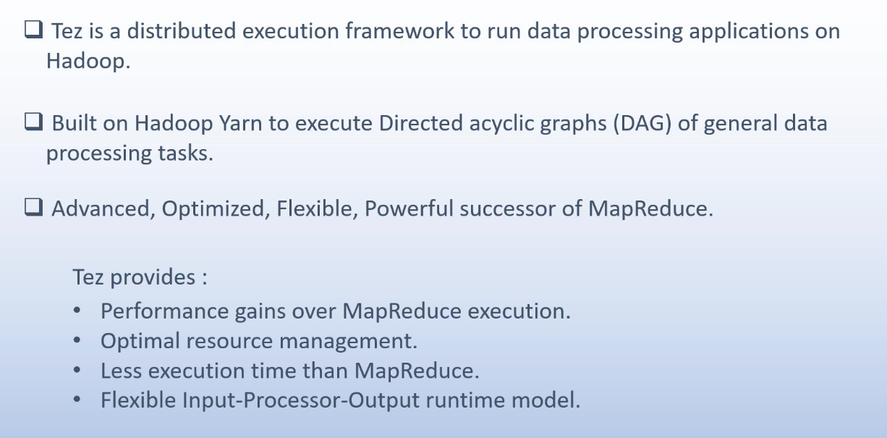



Table properties: -

Skipping header and footer: -





Immutable table: -

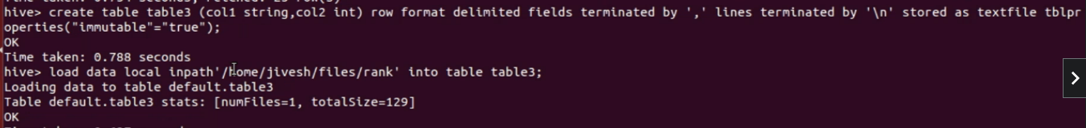

* It will allow first insert into command but won’t allow the sucsessive onces
* Insert overwrite will work as it is because it cleans the data first

Difference between drop and truncate: -

* Drop table will drop the metadata and the actual data both (for managed table)
* Truncate will delete the records only



Purge property: -

* If you drop an internal table it won’t go to the trash instead it will be permanently deleted



Null format property: -

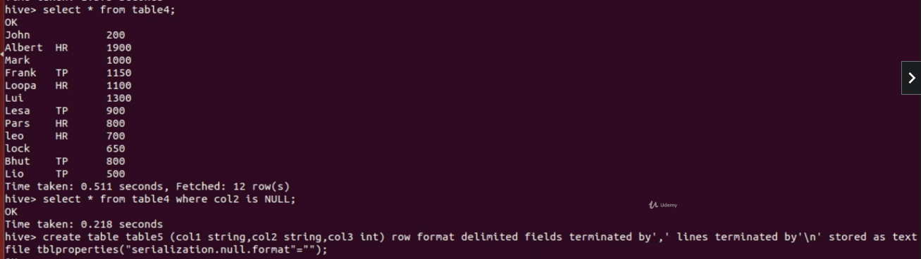

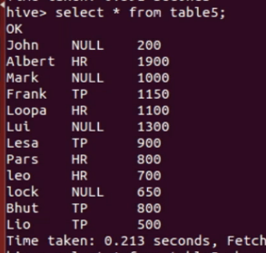

ACID transactions in Hive:

Limitations: -

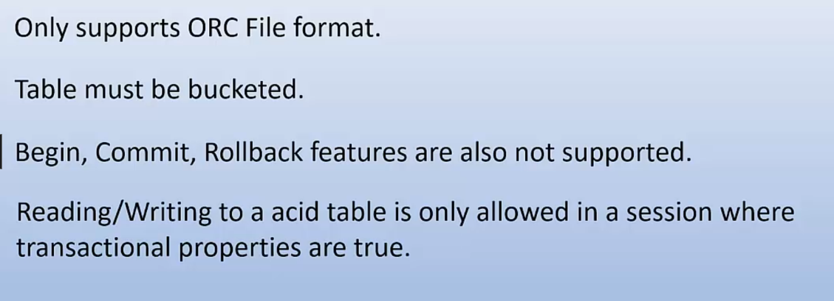

Executing hive queries from bash shell: -



Executing hive quries from hql script: -



Executing hive quries hql script from bash shell: -



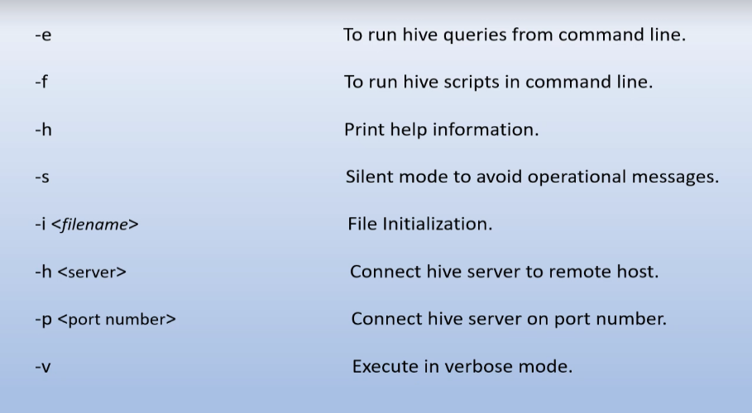

Running Unix and Hadoop command from Hive shell: -

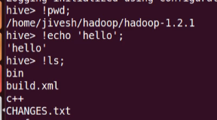

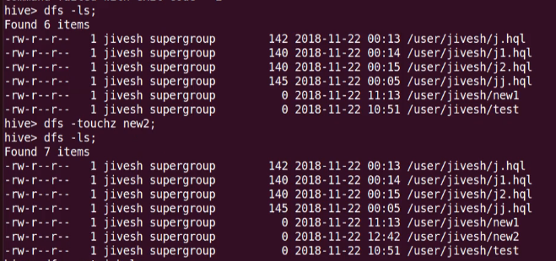

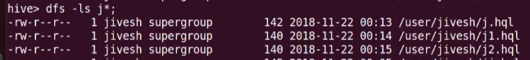

* This won’t work for Unix

Hive variables: -

* Hiveconf
* Hivevar

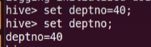









Hive conf variable



* All these variable are valid for this session only

Using variables in bash shell: -









Substituting value of a variable: -

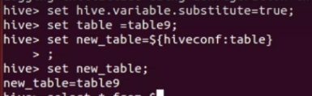

Compression in hive: -

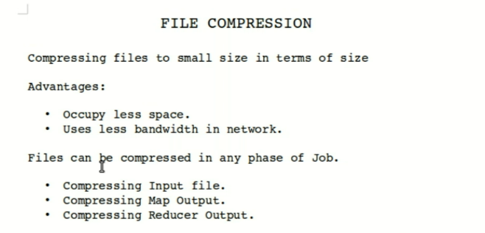

Types of compression available in hive: -

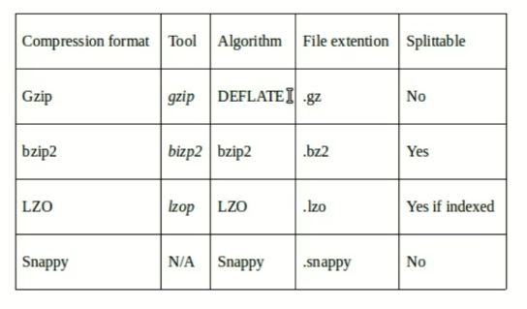

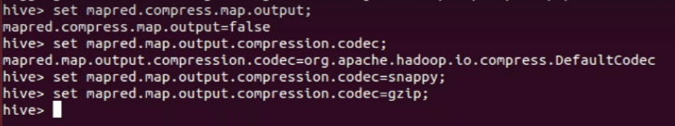

* This is for map output

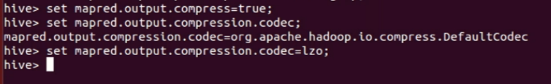

* This is for reducer output

Hiverc file: -

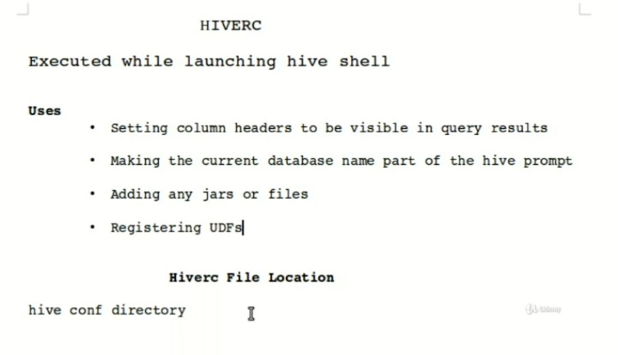

To set some properties for every session: -

